Multiple-choice section

|  |  |  |  |  |  |  |  |  |  |  |  |  |
| --- | --- | --- | --- | --- | --- | --- | --- | --- | --- | --- | --- | --- |
| Question | 1 | 2 | 3 | 4 | 5 | 6 | 7 | 8 | 9 | 10 | 11 | 12 |
| Answer | A | C | B | D | C | A | B | B | C | D | B | A |

Question 1 [4.1]

A

|  |  |  |  |  |
| --- | --- | --- | --- | --- |
| Ones | . | Tenths | Hundredths | Thousandths |
| 1 | . |  |  |  |
| 0 | . | 3 | 6 |  |

0.36 =

Question 2 [4.1]

C

Each interval is 0.01 so the arrow points to 1.02.

Question 3 [4.3]

B

 = 0.666...

= 0.67 (2 d.p.)

Question 4 [4.2]

D

4.245: rounds up to 2.45

Question 5 [4.3]

C

7.2 is 7 wholes and 2 tenths





Question 6 [4.4]

A

A 1.4 – 0.39 = 1.01 B 0.59 + 0.31 = 0.9

C 1.4 – 0.5 = 0.9 D 0.26 + 0.72 = 0.98

1.01 is closest to 1.

Question 7 [4.5]

B

3.2 × 0.2 = 0.64

Question 8 [4.7]

B

0.32 as a percentage

= 0.32 × 100% (move 2 places right)

= 32%

Question 9 [4.8]

C

60% of 40 = 

Simplifies to .

Question 10 [4.8]

D



Because he has 25% of the figures, he needs to collect 75% to complete the set.

Question 11 [4.9]

B

2 dogs: 6 birds

= 2 : 6

= 1 : 3

Question 12 [4.10]

A

40 dogs : 30 kg mince (÷ 10)

= 4 dogs : 3 kg (× 6)

= 24 dogs : 18 kg

Multiple-choice total marks: 12

Short answer section

Question 13 3 marks [4.3, 4.4, 4.7]

(a) To change a fraction as to a decimal, you *multiply* by 100.

(b) A *terminating* decimal is one that does not have a repeating pattern of digits.

(c) The decimal point must be aligned when you *add* / *subtract* two decimals numbers.

Question 14 3 marks [4.1]

(a)

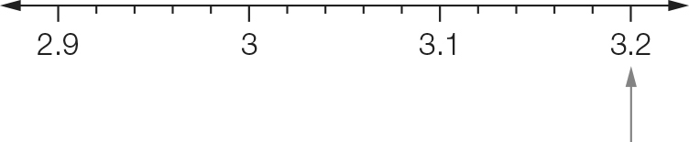

(b)

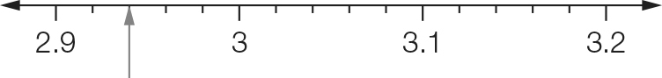

(c)

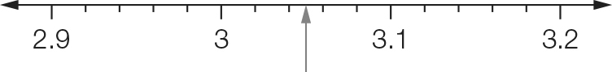

Question 15 2 marks [4.1]

(a) 2 tens, 3 hundredths and 4 thousandths  
 = 20.034 $4+\frac{3}{10}+\frac{6}{1000} = 4.306$

(b) 

Question 16 3 marks [4.1]

(a) 302 > 30.2

(b) 0.0456 > 0.04056

(c) 3.05639 < 3.0653

Question 17 2 marks [4.1]

(a) 6.732, 67.032, 67.32 (b) 0.008 945, 0.080 945, 0.089 450

Question 18 3 marks [4.2, 4.4]

(a) $1.86 rounds up. He would pay $1.90.

(b) He would get $3.10 change:  
$5 – $1.90 = $3.10

Question 19 3 marks [4.2]

(a) 63.732 = 63.7 (1 d.p.)  
rounding down as 3 is next digit

(b) 1.3789 = 1.379 (3 d.p.)  
rounding up as 9 is next digit

(c) 0.8998 = 0.90 (2 d.p.)  
rounding up as 9 is next digit

Question 20 7 marks [4.7]

|  |  |  |
| --- | --- | --- |
| Fraction | Decimal | Percentage |
|  | 0.5 | 50% |
|  | 0.1 | 10% |
|  | 0.25 | 25% |
|  | 0.4 | 40% |
|  | 0.12 | 12% |
|  | 1.75 | 175% |
|  | 0.666… | 66.66..% |
|  | 0.05 | 5% |

Question 21 2 marks [4.3]

(a) 0.666… = or  (b) 3.787 878… = or 

Question 22 4 marks [4.4]

|  |  |
| --- | --- |
| (a) 3 . 0 0 0 21 . 4 0 0 +0 . 2 3 6 24 . 6 3 6 | (b) 4 . 6 4 0 + 01. 41 6 6  5 . 1 0 6 |

Question 23 4 marks [4.4]

(a) 2 . 7 3 5 $1 .3 6 5-$  
 − 0 . 6 3 3  
 2 . 1 0 2

(b) 14.7 – 0.752 = 13.948

Question 24 3 marks [4.5]

(a) 23.8 × 1000 = 23 800 (move decimal point 3 to right)

(b) 0.056 × 6 = 0.336 (3 decimal places)

(c) 45.4 × 400 = 45.4 × 4 × 100  
= 181.6 × 100  
= 18 160

Question 25 4 marks [4.5]

|  |  |
| --- | --- |
| (a) 7 × 6 = 42 0.7 × 0.6 = 0.42 (2 decimal places) | (b) 83 × 2 = 166 0.83 × 0.02 = 0.0166 (4 decimal places) |

Question 26 6 marks [4.6]

(a) 7.95 ÷ 10 000 = 0.00795 (move decimal point 5 to right)

(b) 8.1 ÷ 9 = 0.9

(c) 0.124 ÷ 8 = 0.0155

Question 27 4 marks [4.6]

|  |  |
| --- | --- |
| (a) 8.4 ÷ 60 = 8.4 ÷ 6 ÷ 10 = 0.14 | (b) 4.9 ÷ 0.07 = 490 ÷ 7 = 70 |

Question 28 4 marks [4.8]

|  |  |
| --- | --- |
| (a) | (b) |

Question 29 2 marks [4.8]



Question 30 4 marks [4.9]

|  |  |
| --- | --- |
| (a) 4 : 5 (× 4) = 16 : 20 (÷ 2) = 8 : 10 | (b) 2 : 4 : 5 (× 5) = 10 : 20 : 25 |

Question 31 4 marks [4.10]

|  |  |
| --- | --- |
| (a) $6400 to pave 80 m2 (÷ 10) $640 to pave 8 m2 (× 2) $1280 to pave 16 m2 | (b) 3 minutes to fill a 8 L bucket 180 seconds to fill 8 L bucket (÷ 4) 45 seconds to fill 2 L bucket |

Short answer total: 67

Extended answer section

Question 32 9 marks [4.4, 4.5, 4.6, 4.8, 4.9]

(a) 16.09 – 0.23 = 15.86

(b) Average time = (total of times) ÷ 4  
16.32 + 16.09 + 16.37 + 15.86 = 64.64 $4\overline{)6{}_{}^{2}4.5{}_{}^{1}2}$ 


The average time she ran was 16.16 seconds.

(c) Total number of serves is 3 + 1 + 2 + 1 + 1 = 8 $8\overline{)10{}_{}^{2}7{}_{}^{3}0{}_{}^{6}0}\overline{ .{}_{}^{4}0}$ 
  
The breakfast serving size is: 3 × 1437.5 = 4312.5 kJ

(d) breakfast intake : lunch intake

= 3 : 2

(e) 

Question 33 9 marks [4.5, 4.6, 4.7]

(a) 50 g flour: 40 g butter

= 5 : 4

(b) total of all ingredients: 80 + 50 + 40 + 120 = 290 g

flour: 50 g  


(c) flour : butter : water  
= 50 : 40 : 80 (÷ 2)

= 25 : 20 : 40 (× 3)  
= 75 : 60 : 120  
60 g butter and 120 g water

(d) (i) Sample answer:  
80 g water no cost  
50 g plain flour $0.12 (half unit price)  
40 g butter $0.28 (unit price divide by 10 multiply by 4)  
130 g eggs (2 eggs) $0.80 (price divided by 6)  
Total: 300 g pastry for $1.20  
300 g ready made is 3 × $0.80 = $2.40  
Saving: $2.40 – $1.20 = $1.20

(ii) For 300 g pastry:  
Saving amount: $1.20; Cost of ready made pastry: $2.40  
Using cents: save 120 cents out of 240 cents  


Extended answer total: 18

TOTAL test marks: 97